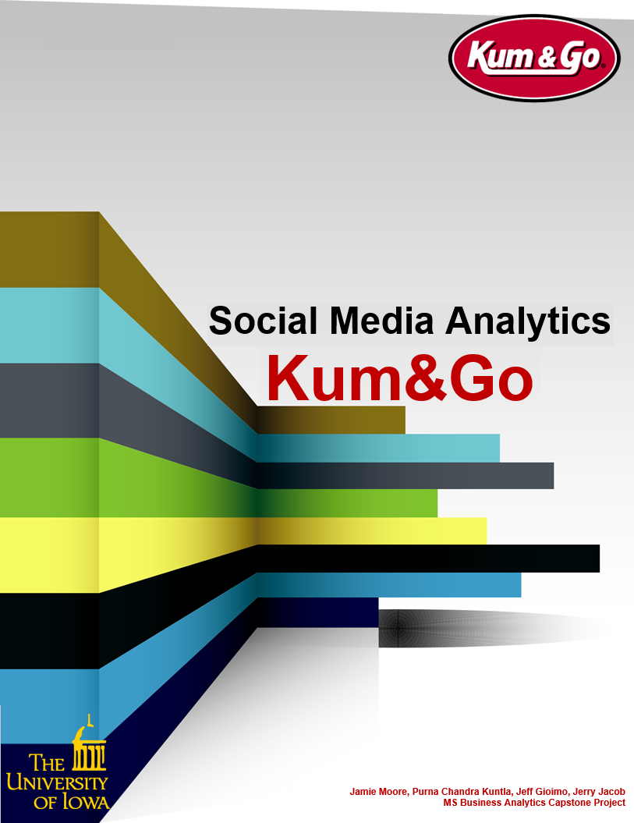



**Table of**

**Contents**

# Synopsis

# Datasets

# Challenges

# Exploratory Analysis

# Decomposition Analysis

# Social Media Scoring

# Sales Analytics

# Loyalty Registrants Analytics

# Rating Analytics

# Findings and Recommendations

Kum & Go is a convenience store chain primarily located in the Midwestern United States. The company, based in Des Moines, Iowa, operates 400 stores in 11 states—primarily in its home state of Iowa. Other states include: Missouri, Kansas, Arkansas, Oklahoma, Nebraska, North Dakota, South Dakota, Minnesota, Montana, Colorado, and Wyoming. Kum & Go was ranked as the 24th-largest convenience store chain in the United States by Convenience Store News’ 2019.

**Synopsis**

The company adopts several marketing technique’s. Loyalty rewards is one of the marketting strategies. Once the user join the rewards program, their purchases will be tracked and they will be awarded freebies and discounts. They will also be asked to answer a survey and rate the store they visited.

Couple of years ago, Kum & Go actively started their marketing campaign in social media sites likes Facebook, Twitter and Instagram. They also created a new position and hired a VP to oversee their social media marketing strategies. With two years into their social media campaign, they want to know whether the social media strategies made any improvements related to their sales, loyalty reward registration or customer ratings.

Social Media Facebook Dataset

**Datasets**

Social Media Twitter Dataset

Social Media Instagram Dataset

Sales Transaction Dataset

Loyalty Signup Dataset

NPS Rating Dataset

Stores Master Dataset

The social media data was only available for 2 years. What were the issues with the small amount of historic data?

Any other challenges with data?

**Challenges**



Seasonality and Trend in Sales

**Exploratory**

-Weekly

-Monthly

Type of Social Media Posts that have high impressions

**Analysis**



* Why a generic scoring was needed?

**Social**

**Media**

**Scoring**

* Different scoring strategies



**Decom-position**

**Analysis**



* Correlation study

**Sales**

**Analytics**

* Regression study (PCA)